THEORY QUESTIONS
1.
Study Figure 1 carefully and use it to answer questions (a) and (f).
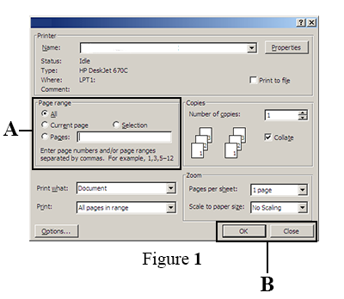
(a)

Write the name of the image shown ...........................
(b)

State the function of each of the following commands on the part labelled A.
(i)

All: ...........................................
(ii)

Current: ...........................................
(iii)

Selection: ...........................................
(iv)

Pages: ...........................................
(c)

Write the keyboard keys combination that could be used to display the image shown.
(d)

Outline the steps involved to display the image shown using the appropriate menu command.
(e)

List two applications that can use the image shown.
(i)

...........................................
(ii)

...........................................
(f)

State the function of each of the commands shown on the part labelled B.
(i)

Ok: ...........................................
(ii)

Close: ...........................................

2.
(a)

What is text formatting?
(b)

List three ways by which a character could be formatted.
(c)

A user typed forem instead of form. Write the steps to be followed to delete tbe letter (e) using the keyboard only.

3.
Use the image shown in Figure 2 to answer questions 3(a) to (c).
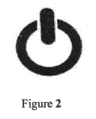
(a)

Write the name image shown.
......................................................
(b)

List three ICT tools that make use of the image shown.
(c)

State two actions a user could take when the image shown is pressed and the device did not respond.
(d)

What is launching as used in computing envirmnen0

4.
(a)

Write three desktop features of a computer.
(b)

State three rules and regulations for the responsible use of the internet in the school's computer laboratory.

5.
Table 1 contains items. Complete the table by indicating against each item whether it is formula,function, text or value in the appropriate dala type column.
Table 1
ITEM | DATA TYPE
Days of the week
=Sum(A2:G2)
4020201010
Days ofthe month
BECE candidates
=A2+G2+M2*P17
233244042761
We are writing ICT exams now
20r020112012
=Product(Al : Zl00)
=B4*C4*H25
202120222023

